Setting up the environment:

1. Install VS code:

Place to get packages

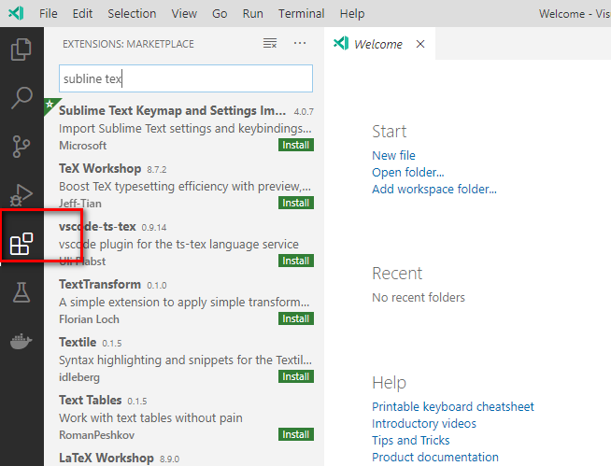

Sublime text keymap

Bable es6/es7

With node js we create a server to run the javascript .

Node is used to create a backend for the mobile or web services

2.Install node js

Nodejs.ord

Cmder commander app

Cmder.net terminal emulator for windows

Terminal:

Issue command and execute JavaScript file

Running command

Check node version

$ node -v

Command to run file Using node

$ node file-name.js